Week-1

1.

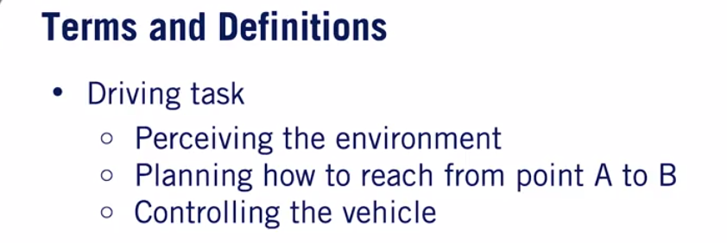

These 3 sub tasks will be running always which constitutes to main driving task

2. 

Operating conditions under which car is deisgned to function

It includes environment,date and time,raodway etc

ODD need to be planend in advacne

3. 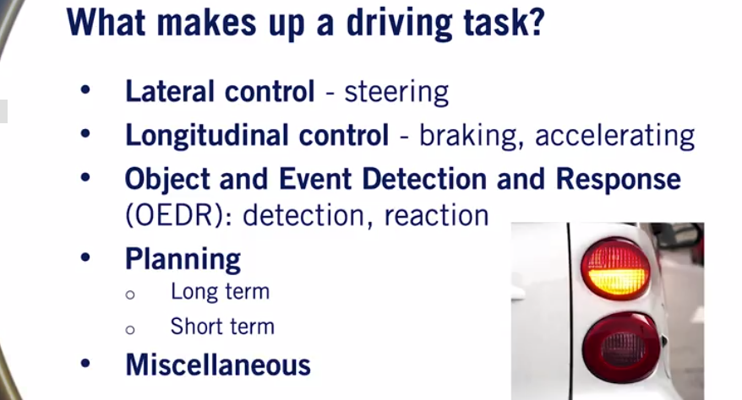

Misc includes hand waving,light signalling,interacting with other driver etc

4. 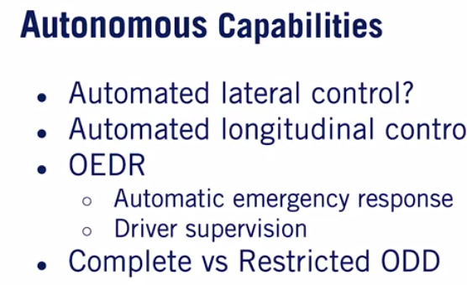

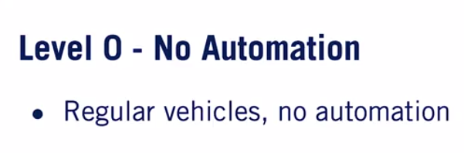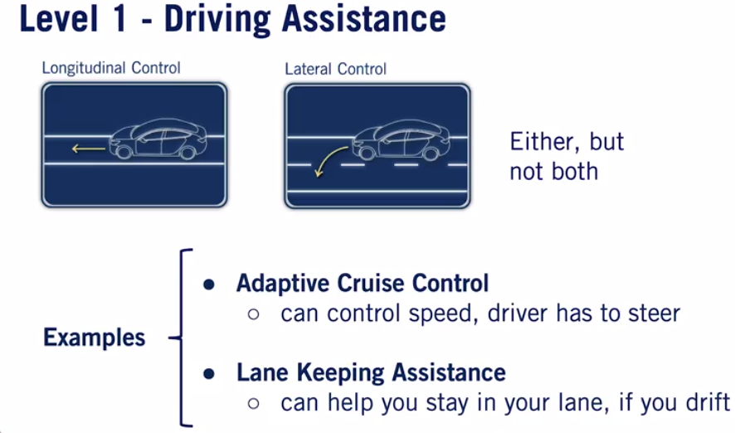

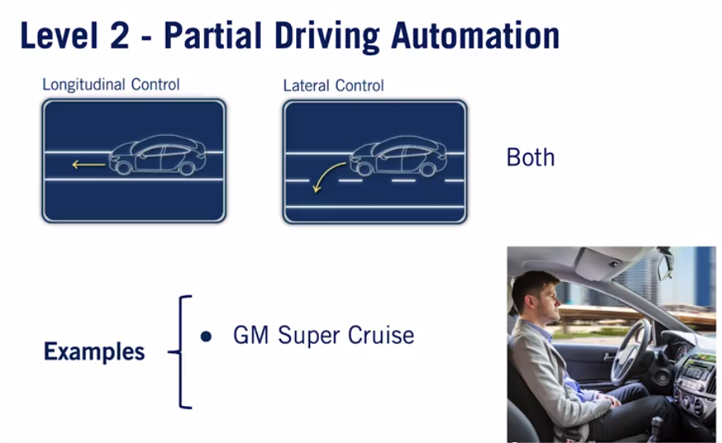 In Level 2 driver monitroign is needed

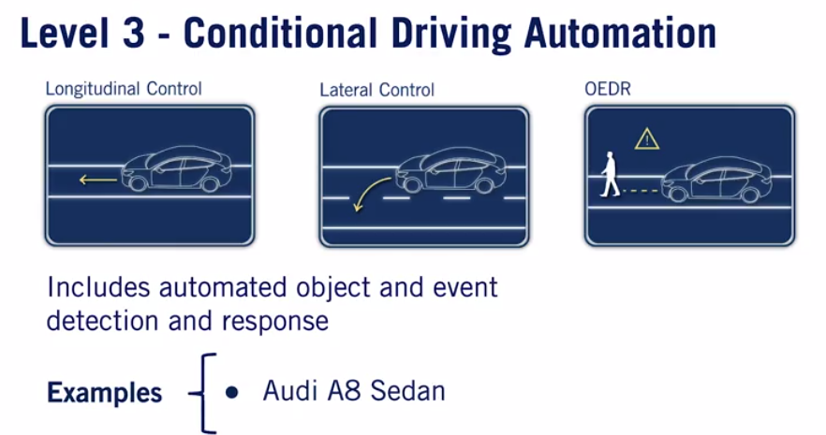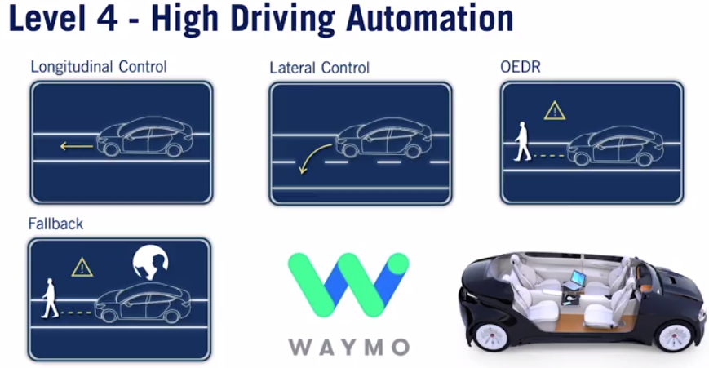

In Level 4.Waymo gives autonomy for limited ODD areas,so driver can rest

